McKenzie, John – senior & junior (based mainly on CALM News 1990)
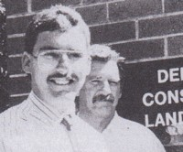
John junior on left, senior on right.
John McKenzie senior graduated from Dwellingup Forests cadet course in 1965. Transferred as Forest Ranger from Manjimup to Grimwade 15.9.1973. Senior Forester at Collie then Wanneroo in 1988. CALMfire coordinator for Perth District in 1997. Retired 1999.
Son John worked in Bunbury Inventory & Planning, on wages. In 1990 was doing a cadetship with the Department and winner of Executive Director’s Scholarship in 1990. This award gives CALM wages staff the opportunity to study and gain qualifications.

